LAMY – 1880s to 1940s
Old Photos from the Palace of the Governors Archives – On Line
Information edited by Connie Doughman

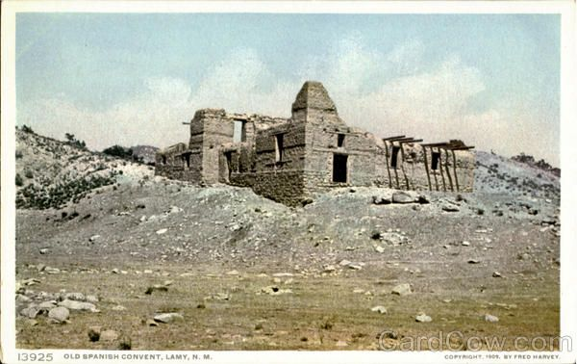
From the caption: Old Spanish Convent Lamy New Mexico Fred Harvey Lamy, between Las Vegas and Albuquerque, was named for the good Archbishop who founded a convent the walls of which are still standing, and who also once taught the Indians in a little adobe school house. At the time of the founding of this convent he was a missionary priest, but afterwards became Archbishop of Santa Fe.

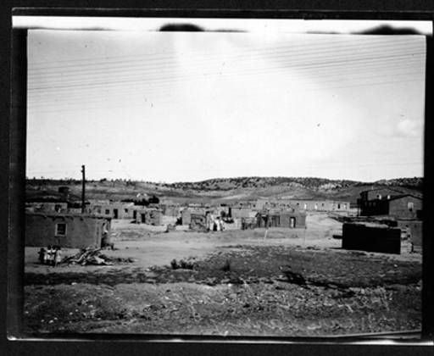 1915
A

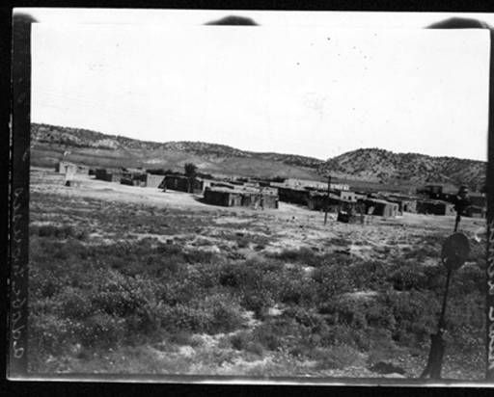 1915
B
See what appears to be the eastern end of Cerro Colorado.

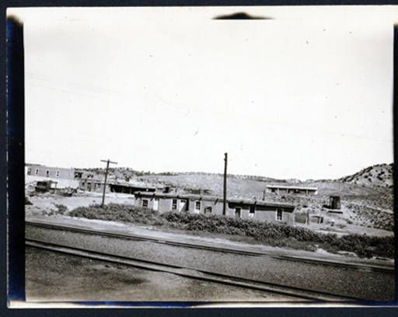 1915
C
Note the eastern end of Cerro Colorado.

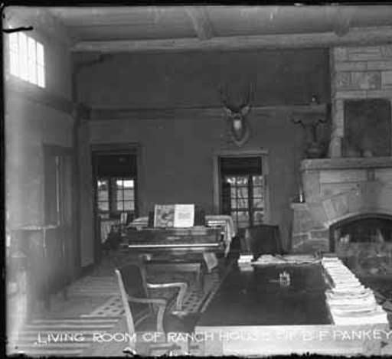
Living room of main house, B.F. Pankey Ranch, Lamy, New Mexico :: Palace of the Governors Photo Archives, T. Harmon Parkhurst Collection 1915
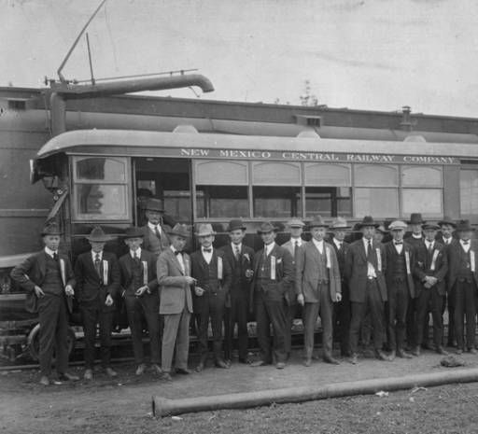
Boosters from Santa Fe, including Arthur Seligman and B.F. Pankey (both 5th from left) at New Mexico Central Railway Company :: Palace of the Governors Photo Archives Collection

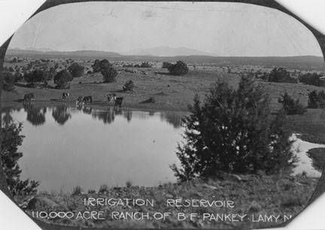
Irrigation reservoir on the 110,000 acre B.F. Pankey Ranch, Lamy, New Mexico :: Palace of the Governors Photo Archives Collection

Note Cerro Colorado and the faint hazy Sangre de Cristos in the background.
I believe this and the one below were taken about the same time period – 1915.

