THE PLAQUE
Information edited by Connie Doughman
Historical Mystery
During our restoration work we discovered a brass plaque attached to a wooden base with the following inscription:

“EN MEMORIA DE JOSE D. SENA
E ISABEL G. DE BACA
Y JOSE CLOUTHIER Y JUANITA BEAUBIEN”

I am interested in further research of the four individuals above and their relationship to Lamy. The ‘G’ in Isabel G. de Baca may stand for Gallego. According to a geneaology posted on the Internet by Jacinto Gallego a woman named Isabel Gallego Baca was born “April 12, 1795 in Hospital de Orbigo (Leon) Espana.” More likely though Isabel is Isabel C de Baca, known to be the wife of Jose D. Sena. Juanita Beaubien was the daughter of Charles Beaubien (b. abt. 1800) and Maria Paula or Pabla Lavato Beaubien. Juanita was born sometime after 1839 and died in 1892. She married Louis Joseph Docither Clouthier who was a French Canadian merchant and rancher.

On the 8th of January 1841, Charles Beaubien and Guadalupe Miranda, two Mexican citizens living in Taos along with a silent partner, Charles Bent, petitioned the Mexican government for a large grant of land along the foothills of the Sangre de Cristo Mountains neighboring the Santa Fe Trail. The Treaty of Guadalupe Hidalgo was signed in 1848 and the US government formally recognized all legitimate Mexican land grants.

Charles Beaubien planned on passing control of this land to his son Narcisco but his son was killed during the Taos Revolt in 1847 and control of the land went to Lucien Maxwell who was married to Luz Beaubien, the sister of Narcisco and Juanita. Joseph Clothier was a French Canadian Catholic and a merchant in Fernando de Taos, where Beaubien also resided. The Maxwell Land Grant has held numerous historical events and extended just east of the Sangre de Cristos all the way into Colorado and almost all along the eastern side of New Mexico.

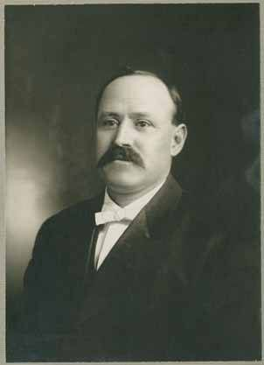
Jose D. Sena, Clerk of the New Mexico Supreme Court
Palace of the Governors Photo Archives Collection 1897 ?
JOSE DOROTEO. SENA, clerk of supreme court, (Rep.) delegate Santa Fe Co.; b. Feb. 15, 1867, in Santa Fe; s. of Jose D. and Isabella D. de (Baca) Sena; educ. St. Michael's College, Santa Fe; Jesuit College, Las Vegas; grad. St. Louis Univ. (Mo.) 1885; taught St. Catherine's Indian School, 1886-7; interpreter Indian agency, 1889; priv. secy. Gov. L. B. Prince, 1891-2; deputy U. S. marshal, 1890-2; merchant Fulton, San Miguel Co., 1893; 1893-6, first chief clerk Terr. Auditor, starting the system of the office; mem. House of Rep., 1897; secy. law compilation com., 1897-8; 1900-2 and 1910-11 secy. Rep. Terr. Cen. Comm; clerk supreme court, 1898-1911; mem, first school board city Santa Fe; nos president; alderman two terms, as president, 1902-4; mayor Santa Fe, 1908-10; appointed as first clerk of the first State Supreme Court; mem. Elks, K.ofC.

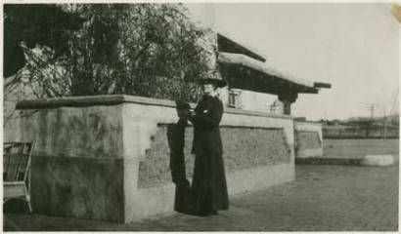
Mrs. Ralph E. Twitchell, railroad station, Lamy, New Mexico :: Palace of the Governors Photo Archives Collection
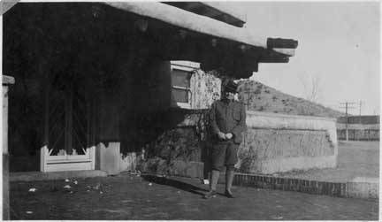
Historian Ralph E. Twitchell, Lamy, New Mexico :: Palace of the Governors Photo Archives Collection
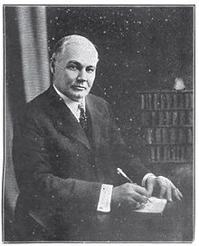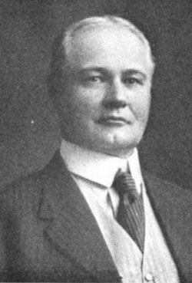
RALPH EMERSON TWITCHELL
Ralph Emerson Twitchell, who went by Ralph E. Twitchell, (1859–1925) was an American historicist, mayor of Santa Fe, New Mexico, and chairman of the Rio Grande Commission, which drafted a treaty between the United States and Mexico leading to the building of the Elephant Butte Dam in his state. Twitchell helped organize the first National Irrigation Congress in 1891. For forty-three years he was a member of the legal department of the Santa Fe Railroad. He was prosecuting attorney for Santa Fe County and special counsel for the U.S. Department of the Interior dealing with Native American and water-rights cases.^{[1]}
He died August 25, 1925, at the age of 68 in Los Angeles, California, leaving his second wife, Estella B. Twitchell, as well as two brothers, Waldo C. Twitchell and W.B. Twitchell.^{[1]}
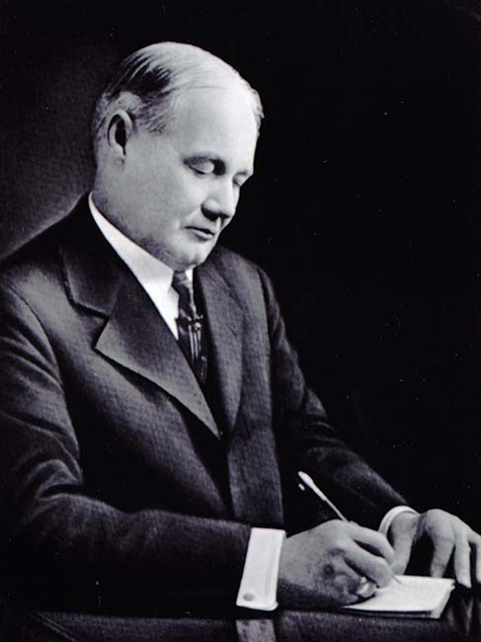
By Richard Flint and Shirley Cushing Flint
Ralph Emerson Twitchell was born in 1859, less than a year before the outbreak of the Civil War, in Ann Arbor, Michigan, to Daniel Sawin and Delia Scott Twitchell. He was named for the great American philosopher and abolitionist, Ralph Waldo Emerson. In 1882 at the age of 23, Twitchell received a law degree from the University of Michigan and moved immediately to Santa Fe, New Mexico. There he joined the office of Henry L. Waldo, an attorney for the Atchison, Topeka, and Santa Fe Railway. For the remainder of his life, Twitchell was connected with the AT&SF legal department.
The year 1885 was a very busy one for Twitchell. In that year, at the age of 26, he was elected president of the New Mexico Bar Association, married Margaret Olivia Collins, and was among the organizers of the New Mexico Territorial Militia. Later, he served as the militia's judge advocate, with the rank of colonel and was commonly referred to as Col. Twitchell, thereafter. His marriage to Margaret lasted until 1899, when she died. He then married Estelle Burton, who over the years collaborated in research and writing with her husband.
Twitchell was very active in local Santa Fe politics and government. From 1889 to 1892 he was district attorney for New Mexico's First Judicial District. In 1893 he served as mayor of the city of Santa Fe and afterwards was district attorney for Santa Fe County. He was special assistant to the U.S. Attorney General for Pueblo land titles. A prominent Republican, Twitchell held the office of chair of the party's territorial central committee during the years 1902 and 1903.
Twitchell's interest in the history of New Mexico occupied much of his attention and time, often-overshadowing political duties and his work as a railroad attorney. That interest was first piqued by his acquaintance with Adolph Bandelier. In the early 1880s Bandelier was doing historical research in the Spanish and Mexican period records held by the territorial government.
Twitchell saw an affinity between the legal profession and the study of history, particularly research in documentary sources. He would later state that: "The writer of history, in his presentation of events occurring during a given period, may be compared to the lawyer in the preparation and presentation of a case...So the historical writer should not be merely a narrator, chronicler. He should not be the witness giving testimony. He should be the lawyer, the advocate, the painter, the artist evolving an historical picture for the mind and creating impressions which result in conclusions."
He was not alone in his opinion that an essential connection existed between the pursuits of law and history. Concerns over the establishment of legal precedents led many other lawyers to similar conclusions. In Santa Fe, a number of Twitchell's legal colleagues, including L. Bradford Prince and Thomas B. Catron, were also aficionados of the study of history and maintained large personal libraries that included both published works on historical subjects and manuscript records of historical value. Twitchell was a regular user of his friends' libraries and patron of the "Santa Fe Archives." In May 1892, he was one of several people who helped rescue the documents in that archive from a fire that destroyed the territorial capitol building.
Convinced that there was a need for a comprehensive history of New Mexico that would be "available to the person of moderate means," he published in 1911 and 1912 Leading Facts in New Mexico History. The information contained in that two-volume narrative history, and its subsequent three volumes, derived from documents and books from the territorial, Prince, and Catron collections, as well as his own. Leading Facts proved to be Twitchell's best-known publication. It was considered authoritative for generations. Its contents were largely paraphrases of its source materials. Or as Twitchell wrote: "a great deal of the work found in the pages [of the book] may best be termed editing." Leading Facts included maps prepared under Twitchell's direction by his son Waldo.
Twitchell was intensely patriotic when it came to the United States and in the 1890s was a member of the Knights of Liberty, a secret society often identified with the Santa Fe Ring. He was also an advocate for the English-only movement, which earned him the animosity of many of New Mexico's Hispano citizens. He was, nevertheless, an enthusiastic booster of New Mexico. He hoped that his lectures and publications would "impress upon the reader's mind the fortitude, the courage, the suffering, and the martyrdom of those who first brought to New Mexico the banner of Christianity and civilization." He often disparaged the Native American past, as "primitive" and "pagan," if not exotic and romantic.
Twitchell was the most prolific New Mexico historian of his period, although his works were often seen as biased. One such example is The History of the Military Occupation of the Territory of New Mexico from 1846 to 1851 by the Government of the United States published in 1909. While he was very young Twitchell had lived in Jackson County, Missouri, where he knew Alexander Doniphan and John W. Reid, both of whom had been officers during the American invasion of Nuevo México in 1846. They recounted to him their version of the events of the U.S.- Mexico War. Twitchell portrayed the invasion as an important part of the glorious "winning of the West." He called the invasion "the greatest military achievement of modern times" and insisted that "such deeds should appeal to every loyal American." Naturally, many Nuevo Mexicanos saw the actions of the U.S. military very differently.
Twitchell was a longtime member of the Historical Society of New Mexico and its president in 1924. He was a staunch friend of Edgar Lee Hewett, director of the School of American Research and the Museum of New Mexico. Hewett and Twitchell worked together on numerous occasions. Twitchell chaired the committee in charge of the New Mexico building at the Panama-California Exposition held in 1915 in San Diego, while Hewett oversaw the preparation of exhibits for the exposition. Twitchell served on the board of regents of the Museum of New Mexico and of the managing committee of the School of American Research for several years during Hewett's long tenure as director. And from 1913 to 1916 Twitchell was the founding editor of Old Santa Fe--A Magazine of History, Archaeology, Genealogy, and Biography, for which Hewett's protege Lansing Bloom was assistant editor.
In 1914 Twitchell published "The Spanish Archives of New Mexico," the first calendar and guide to the manuscript documents from the Spanish colonial period that he had previously helped save from destruction by fire. It served as the basis for the Calendar of the Microfilm Edition of the Spanish Archives of New Mexico, 1621-1821 and the Calendar to the Microfilm Edition of the Land Records of New Mexico, which were prepared through the New Mexico State Records Center and Archives in the 1980s. Those two guides still serve as the principal aids for navigating through the most important collection of Spanish manuscript sources pertaining to New Mexico.
Twitchell held the office of president of the Santa Fe Chamber of Commerce and, from 1919 through 1922 was director of the Santa Fe Fiesta. This once again brought him into partnership with Hewett, since it was during this time that the School of American Research had responsibility for organizing and planning most fiesta activities. Twitchell was a moving force behind publicity for New Mexico done by AT&SF, was a key advocate for New Mexico statehood, and he designed the state's first flag in 1915.
As he angered many Hispanos with his English-only stance and his history of the Mexican War, he also ignited complaints from Pueblos by screening a film he had produced of the Taos Corn Dance. He added insult to injury by screening the film again after one copy of it mysteriously disappeared. Further antagonism between Twitchell and Native Americans came in 1922, when he was one of the principal authors of what came to be known as the Bursum Bill: "An Act To Quiet Title to Lands within Pueblo Indian Land Grants." Twitchell testified in favor of the bill before a U.S. Senate committee. Under questioning by senators, it became obvious that the bill masked a land grab by certain New Mexicans. It would have recognized titles to all non-Indian holdings on Pueblo lands that had been held for at least 10 years and would have placed authority over Indian land and water rights in state courts. In opposition to the bill, the Pueblos formed an All-Pueblos Council in November 1922. Aided by lobbying by the General Federation of Women's Clubs, the Council was able to defeat the Bursum Bill, which would have resulted in the loss of thousands of acres of Pueblo land.
Twitchell died at the Clara Barton Hospital, Los Angeles, on August 26, 1925, from complications following surgery he had had in Santa Fe. He asked to be buried below the Cross of the Martyrs on Fort Marcy hill in Santa Fe. There were many objections to that proposal, and he was buried in Fairview Cemetery, along with many other prominent Santa Feans of the day.
Sources Used:
Chauvenet, Beatrice. Hewett and Friends: A Biography of Santa Fe's Vibrant Era. Santa Fe: Museum of New Mexico Press, 1983.
Melzer, Richard. "Foreword." In The Leading Facts of New Mexican History. Facsimile of the original 1912 edition. Santa Fe: Sunstone Press, in preparation.
"Ralph Emerson Twitchell." The Reno Evening Gazette, Wednesday, August 26, 1925.
Twitchell, Ralph Emerson. The History of the Military Occupation of the territory of New Mexico from 1846 to 1851 by the Government of the United States. Danville, Illinois: Interstate Printers and Publishers, 1909; reprinted, Chicago: Rio Grande Press, 1963.

THE CONSPIRACY OF DECEMBER, 1846
When Stephen Watts Kearny occupied Santa Fe, the Spanish old guard led by Diego and Eugenio Archuleta and Tomas Ortiz conspired to take control of the formerly Spanish controlled Santa Fe. The shift from Spanish control to American control overpowered the failed conspiracy. In January of 1847 Charles Bent and Narcisco Beaubien were killed in the Taos Revolt along with several others. This was all connected to the discontent of the Spanish now having lost control of the area to the Americans.
https://books.google.com/books?id=WDDTHUo_yKQC&pg=PA255&lpg=PA255&dq=the+conspiracy+of+December,+1846+-+NM&source=bl&ots=v-_JF-cJP5&sig=ZMNrHuFw5p-GmgOdMIUN-V8VQGI&hl=en&sa=X&ved=0CCEQ6AEwAWoVChMIpqfb3_aLxwIVhFaSCh1WVQsS#v=onepage&q=the%20conspiracy%20of%20December%2C%201846%20-%20NM&f=false

ISABEL G. DE BACA SENA

Ralph Twitchell’s book, Old Santa Fe, page 279 and also in his book, The History of the Military Occupation of the Territory of New Mexico, page 317.

https://books.google.com/books?id=mR0TAAAAYAAJ&pg=PA317&lpg=PA317&dq=Dona+Isabel+Cabeza+de+Baca&source=bl&ots=ZFeD651pEp&sig=x9wRy8GrwDYezJ3aM1YT2nPjaa0&hl=en&sa=X&ved=0CCsQ6AEwAmoVChMImrWh-dyLxwIVBAOSCh0rGQWU#v=onepage&q=Dona%20Isabel%20Cabeza%20de%20Baca&f=false
“The Vicario, Juan Filipe Ortiz, many times asked my father, Antonio Matias Ortiz, to join the conspiracy, but he refused to do so. Son Miguel E. Pino also told me, at the time I was serving as a volunteer at the government post at Galisteo, in 1856 and 1857, at the home of Don Nicolas Pino, that the plan of the conspiracy, as drafted and signed by all the conspirators, was taken by Don Miguel E. Pino and hidden at the house of his mother, Dona Ana Maria Baca, who was the wife of Don Pedro Bautista Pino. It was hidden in the ceiling. It was never found.”
As to the manner of the escape of his cousin, Tomas Ortiz, on Clemente says that after Don Tomas arrived at Galisteo, from Santa Fe, he rode by way of the Estancia valley through Manzano and Abo, across the Gallinas mountains to the junction of the Rio Bonito and Ruidoso, at or near the present site of Ft. Stanton, thence to the ford of the Rio Grande, known as the Ponce de Leon ford, and thence to Chihuahua.
Dona Isabel Cabeza de Baca, widow of Don Jose D. Sena, in her life time, in discussing the facts relative to the conspiracy of December, 1846, told of the escape of Tomas Ortiz from Santa FE. Mrs. Sena was the daughter of Domingo C. de Baca, one of the conspirators, and her mother was Josefa Ortiz, a sister of Don Tomas Ortiz, the leader of the conspiracy. Mrs. Sena says that the soldiers came to the house of the vicario, Juan Filipe Ortiz, looking for his brother, Don Tomas. They decided to make a search of the store-room (dispensa), where they believed Tomas was hiding; when they entered the room the women all fled except Ana Maria Ortiz, who was watching some toast (costales de biscocho); in this store room there was also large supply of provisions, which that night was sent to Galisteo on pack mules awaiting the coming of Don Tomas. Ana Maria Ortiz was the wife of Eugenio Archuleta, a brother of Don Diego Archuleta. During the time that the soldiers were thus searching the house, Don Tomas was hiding on a balcony facing the garden of the icar-general. When the soldiers left, he was taken from the balcony and dressed in the garb of a servant girl, and from his place on the balcony was lifted with ropes to the roof of the chapel (on the right-hand side of the cathedral); he was then lowered into the garden and taken by Pedro Trujillo in the house of his mistress, a woman named Peregrina, who lived on the Arroyo Sais, above where the arroyo crosses Palace avenue in Santa Fe. Trujillo carried Tomas Ortiz on his back and passed over a trail leading to the rear of where is now located Saint Vincent’s sanatorium. On the way to the arroyo where Dona Peregrina lived, Trujillo was met by a squad of soldiers, who asked him whom he was carrying, and he told them it was his daughter, who was very sick. They finally reached the house of Dona Peregrina.
Meanwhile preparations had been made for two horses, the fleetest of any in Santa e; these were stationed on the bank of the Santa Fe river, about two hundred yards from the house of Peregrina. After taking Ortiz to the house, Trujillo went to the river, where the horses had been brought. Shortly Ortiz came out, dressed as a servant girl and carrying a tinaja (water jar) on his head, evidently going to the river for water. As he was proceeding down the arroyo he was met by some soldiers on foot, who asked if “she” knew where lived a woman named Peregrina, and if so, whether Tomas Ortiz was at her house. Ortiz replied “yes” and pointing out the house, said, “Ortiz is there in the kitchen now.” The soldiers then proceeded to the house, and Ortiz, picking up his skirts and throwing them over his shoulder, ran down the arroyo toward the river. As he did so, two Mexican women standing near a small adobe house, shouted to the soldiers, “Haya va Tomas Ortiz, Gringos pendejos!” Ortiz reached the river, where with his friend Trujillo, he mounted his horse and was soon lost to sight on his way to Galisteo, where he joined with Don Francisco Ortiz y Tafoya, who had been sent to Galisteo by the vicario with fresh horses, money and provisions for his flight to Chihuahua.
Don Miguel E Pino and Don Nicolas Pino did not take any part in the revolutionary movement afterwards. They had nothing to do with the outbreak at Taos, and Don Nicolas, after he was released from prison in Santa Fe, took oath of allegiance …………

JOSE D SENA
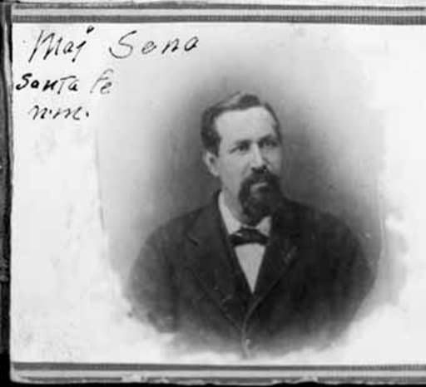
Major Jose D. Sena, Albuquerque, New Mexico :: Palace of the Governors Photo Archives Collection 1880 ?
http://lacasasena.com/restaurant_sena-plaza/
Sena Plaza is one of the oldest surviving houses in Santa Fe. Located just one block from the city’s plaza, and just across the street from The St. Francis Cathedral. La Casa Sena, which means ” the Sena House”, occupies an old hacienda style adobe. The Sena family was one of the oldest and most notable in Santa Fe. The land La Casa Sena was built on, was originally granted to Captain Arias de Quiros by General Diego de Vargas, who reconquered Santa Fe for the Spanish in 1693. The property was then deeded through family to the wife of Juan Sena and then to their son, Major Jose Sena. In 1864, Major Sena married Dona Isabel Cabeza de Baca and on the inherited land built a small adobe home. Major Sena extended the original structure into a thirty-three room hacienda in 1868, long before New Mexico was to become a state.
Even with it’s thirty-three rooms there wasn’t much room to spare. Isabel produced twenty-two children for the family, although only eleven survived. The Major was a very social man and entertained the dignitaries of the day, such as frontiersman Kit Carson. Even then the house of Sena served the finest cuisine of the region, featuring venison, rabbit, buffalo and the many chiles native to this area. Spanish hospitality included day-long feasts, with sports, games and dancing.
A ballroom on the second floor of the west wing of the house was often filled with song and merriment. This ballroom also temporarily housed the legislature when the original capital burned in 1892. The hacienda included a chicken house, coach house, servants’ quarters, storerooms and two wells, one of which still exists today. The courtyard, now green and beautiful, was then bare earth, all vegetation eaten by the goats that inhabited it. The main dining room of La Casa Sena now stands where the stables once were.
After Major Sena died, the land was divided among the six surviving children, and in 1927 they deeded the land to Senator Bronson Cutting and his two sisters, Martha and Amelia White. Renovations began and a Tea Room was built in the area where the stables had once been. A second floor was added to the east wing and all of the other rooms became stores or offices. One of these offices was used in the 1940’s by the Manhattan Project, which later developed the Atomic Bomb in nearby Los Alamos.
In the early 1980’s, art dealer Gerald Peters bought the historic building and renovated it to it’s former grandeur, all the while, protecting it’s architectural integrity. In 1983, La Casa Sena opened in the space once occupied by the Tea Room, and food and song once again filled the old Sena house.

Links: http://engvc.unm.edu/Publications/BestStudentWriting/Bestof101/SallyOrozco_Bestof101.pdf

LOUIS JOSE D CLOTHIER

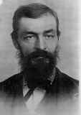

Louis Jose D. Clothier – Born about 1844January 9, 1836 in Canada, a French Catholic. A merchant in Fernando de Taos and in Springer, NM in 1910 census listed as farmer. In the 1880 Reyado, Colfax County census he was listed as a stock raiser. Death 1 Nov 1893 in Taos, New Mexico or Las Vegas, San Miguel, NM

JUANITA BEAUBIEN CLOTHIER

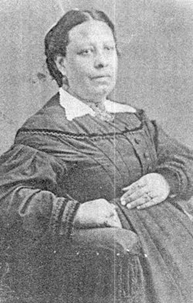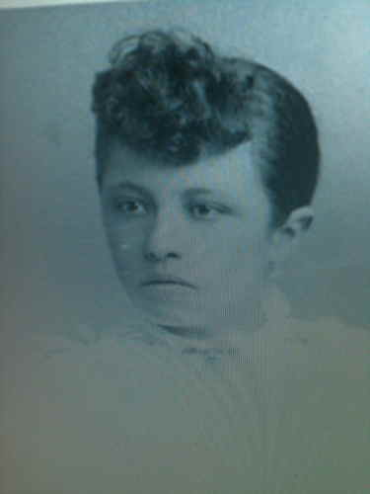

Juanita Baubien – Birth 6 July 1838 in Ranchito de la Purisima Concepcion, Taos, New Mexico. Death 14 Nov 1892 in Taos, Taos, New Mexico Territory

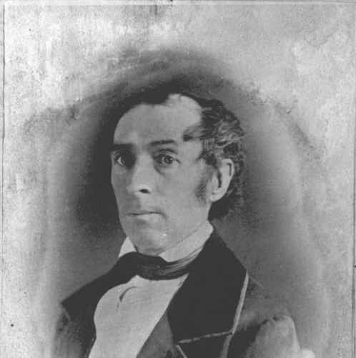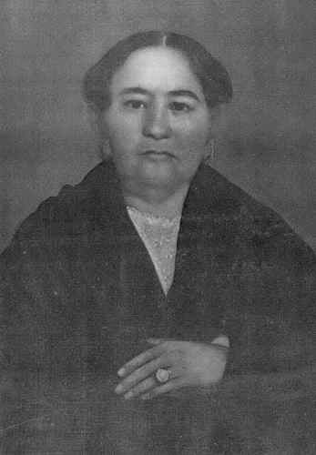
Charles Beaubien and Maria Pabla Lovato Baubien

Charles Beaubien

Birth: 22 October 1800 in Trois-Rivieres, Quebec, CAN oe Sainte Jean de Baptiste, Nicolet, Quebec, CAN
Death: 6 or 10 February 1864 in Taos, Taos County, New Mexico, USA

Maria Pabla Lovato Beaubien

Birth: 28 December 1811 in Taos, Taos, New Mexico, United States
Death: 13 August 1864 in Cimarron, Colfax County, New Mexico

Charles Beaubien
By Priscilla Shannon Gutiérrez

Of the dozens of French trappers and traders who made their way to Taos in the early to middle half of the nineteenth century, none had as great an impact on the history and development of the town as Carlos Hipolite Beaubien. During the four decades Beaubien called Taos home, he managed to use his education and know-how to become one of its wealthiest and most influential citizens and public servants. Not surprisingly, Beaubien was friend and confidant to many of the Southwest's most famous mountain men and traders, including the Bent brothers, Lucien Maxwell, Richens “Dick” Wootton, Kit Carson, Gervais Nolan, and the Robidoux brothers.
Born Alexis Hipolite Beaubien in Saint-Jean Baptiste de Nicolet, Quebec, Canada, in October, 1800, he was named after his uncle, Alexis Durocher, a priest who presided over the child's baptism. Perhaps it was the influence of his uncle that convinced the young Beaubien to enter the seminary around 1812. He remained there for eight years perfecting his French and Latin, while studying the classics and advanced theology. In later years, his education at the seminary set him apart from many of his contemporaries in Taos, and most likely gave him an edge as a businessman.
For reasons unknown, in 1821, Beaubien decided to leave the seminary and set out on his own. Assuming the name Charles, he made his way into the United States, eventually arriving in the St. Louis area. At Kaskaskia, 50 miles south of St. Louis, Beaubien made the acquaintance of the various French-Canadian families residing there including the Choteau's and the Menard's, both well-educated, and considered founding families of the town. For a short time, Beaubien found work as a clerk for Auguste Choteau in his St. Louis store before heading west. Coincidentally, his future son-in-law, Lucien Maxwell, was grandson to Auguste Pierre Choteau and Pierre Menard, both of whom operated lucrative trading businesses with the Indians. Most likely Beaubien also made the acquaintance of Silas Bent's family, including his sons, Charles and William, who would soon make a name for themselves in the Santa Fe trade and create a sprawling empire.
Sometime that year, Beaubien joined a trapping party headed west that included LeDoux, Bijeau, Duchesne, and Gremer. The group of 15 or so trappers made their way south along the Rockies from the Missouri River. At some point, Mexican officials encountered the group and brought them back to Taos. Perhaps while there, news of Mexican Independence, and its accompanying permission to trade with Americans arrived because the group apparently was released as there is no record of them being sent to Mexico City. In the spring of 1824, Beaubien again entered Indian territory along with Antoine Robidoux, after receiving a permit to trap from Superintendent of Indian Affairs William Clark (of Lewis and Clark fame) in December of the previous year.
While trappers continued to make their way to the Colorado and Green rivers, word got around of the wealth of the Mexican beaver trade. Augustus Storrs, in an 1824 letter to Senator Thomas Hart Benton, stated that he had brought in over $10,000 of beaver pelt from a recent trade caravan. Taos' location provided a convenient gateway to the southern Rocky Mountains. At that time, beaver could still be found within a reasonable distance from Taos as the rivers had not yet been trapped out, and the town offered a place to get supplies, as well as a welcomed respite from the hard life of trapping. Especially prized, after long months of solitude and deprivation, was the warm hospitality of the Mexican women, whose dark beauty trappers found difficult to ignore. Also welcomed was the local whiskey known as aguardiente or Taos lightning that provided a warmth of its own. While some wintered over in Taos, many trappers set out during the later winter months to lay traps because the frigid weather produced prime beaver pelts, heavy with fur.
During this time, Beaubien made the acquaintance of Ceran St. Vrain, who himself was trapping, not yet having made the shift to merchant that would come the following decade. However, by 1824, St. Vrain had already made Taos his home, was learning the Spanish language, and had married the first of his four wives - a Mexican woman by the name of María Dolores Paula Luna. While both appear to have made Taos their home base, they continued to trap and joined Baptiste Lacroix on several forays into the mountains during the 1820's, and Beaubien joined Sylvestre Pratte on an expedition in January, 1827.
In 1826, Beaubien received an early guía, number 23, from the Mexican Government to travel to Chihuahua as a trader. He hauled 2,000 yards of fabric, 5 dozen mirrors, umbrellas, ribbons, 100 pairs of shoes, buttons, combs, and beads on his caravan. The venture must have proved profitable as it would appear that at this point Beaubien, never a real outdoor enthusiast, was beginning to consider himself more of a merchant than trapper.
Likely, Charles' shift toward the life of a merchant and businessman was influenced by his earlier education at the seminary and the opportunity to put it to good use. His falling in love with Taos resident, Pabla Lovato, also likely influenced the decision to maintain a more permanent residence in town. In 1827, Beaubien petitioned the local Mexican Government for permission to become a resident of Taos. His petition was approved and later in the year, on December 11, 1827, Beaubien wed Pabla, with none other than Padre Antonio José Martínez presiding over the ceremony. In hopes of delaying the marriage of extranjero Beaubien, Padre Martínez had forced the couple to get permission from the bishop in Durango. After several months of waiting, the approval came through and the marriage proceeded in spite of Martínez's opposition.
Six weeks later, their first child, José Narciso was born. The following year, on August 3rd, a second child, María Luisa Antonia, was born.
Later, María would become St. Vrain's second common-law wife for a short time. We do not know if María died an early death or if she parted ways with St. Vrain. Our only account of her comes from Lewis Garrard who considered her a dark-eyed, languid beauty.
On June 25, 1829, along with Gervais Nolan, John Roland, Antoine Robidoux and his brother Louis; Beaubien became a Mexican citizen and adopted the Spanish spelling of his first name. Thereafter he was known as Carlos Beaubien. In the years to come, Nolan would remain one of Beaubien's closest friends, in spite of the fact that he was an illiterate trapper. That same year, Beaubien's third child, María de la Luz, was born on June 24th.
Beaubien's influence in affairs in northern Mexico increased during the following years and his merchandise store on the south side of the plaza did a solid business. Known for his ability to judge pelts, he often bought and sold furs for his friends in the Santa Fe trade including St. Vrain, the Bent brothers, and Stephen Louis Lee. Carlos also began to assume prominence in political affairs, becoming the first elector for two Taos precincts in 1832, and First Alcalde of Taos in 1834, much to the chagrin of Padre Martínez, a staunch Mexican patriot.
Indeed, in subsequent years, in spite of having presided over his marriage, the Padre directed much of his anger and anti-foreigner diatribes toward Carlos and his friend, Charles Bent – now also a resident who handled the business end of the Bent - St. Vrain operations in Taos and Santa Fe. Bent was romantically involved with the prominent widow, Ignacia Jaramillo, who soon became his common-law wife. Through his alliance with Ignacia, Bent later became brother-in-law to Kit Carson when he married Ignacia's sister Josepha in 1844. Padre Martínez, suspicious of all foreigners, considered both Beaubien and Bent opportunists who would hand over Mexico to foreigners at the drop of a hat. Time would show that the Padre's suspicions were not without merit.
During this decade, the Beaubien family continued to increase in size. Leonora was born on March 27, 1833; and another daughter Teodora was born on January 20, 1835; but died shortly after birth from unknown causes. Yet another daughter, Juana, was born on July 6, 1838. The family moved to larger quarters south of Our Lady of Guadalupe Church on present-day Ledoux Street to accommodate the growing family. Prior to being named Ledoux, the street was known as Camino de Beaubien. Old Sanborn Insurance maps still carry the name, even though the spelling was anglicized into Bovien. Other spellings of the name include Bobian.
Manuel Armijo, Governor of the territory at the time, appeared to play both sides of the proverbial fence. In 1840, he issued an edict that all native-born citizens were exempt from paying taxes on their storehouses and shops, putting the complete burden of taxes on all naturalized citizens. It was a way to continue receiving revenue on goods, and made himself look simpático to the nativist minded residents. Naturally, the edict infuriated Bent, Lee, Beaubien and others who saw it as a direct affront to their commercial interests.
Curiously, around the same time, Armijo didn't have a problem approving the petition of Beaubien and Provincial Secretary of State Guadalupe Miranda. Armijo knew how to operate under the table and perhaps for a sum of money, agreed the large tract of land east of the Sangre de Cristo Mountains was theirs. The Old Taos Trail marked the western boundary of the tract; Raton Pass marked the eastern boundary, and Sibley's gap approximated the southern boundary of the tract. Thus, the beginnings of the vast Beaubien-Miranda-Maxwell Grant was put into motion.
Beaubien's family continued to expand. Not only did he and Pabla welcome a second son, Juan Lucas, born on July 6, 1840; they welcomed another daughter on May 17, 1842, named Teodora after the first infant who had died; and yet another, Petra, arrived on June 29, 1844. The Beaubien clan also added a son-in-law, Lucien Maxwell, when he took María de la Luz's hand in marriage at the tender age of 14, as was the custom at the time. Maxwell was employed as a freighter for the Bent brothers, and worked as a scout during John C. Fremont's first expedition west. No doubt Beaubien's familiarity with the Menard and Choteau families influenced his acceptance of Maxwell as a son-in-law. He knew Lucien came from good French stock.
During the years 1843 – 1846, Carlos expanded his successful mercantile business, often procuring his wares through Choteau's store in St. Louis, at times making the trip himself. Beaubien also began to devote more effort to improving the grant east of the mountains. In exchange for a one-fourth interest that was illegal under Mexican law, Charles Bent secretly agreed to supervise the development of colonies along the Poñil, Rayado, Cimarrón and Vermejo Rivers. Establishment of long-term settlements proved difficult due to marauding Indians who considered the area prime hunting grounds. Padre Martínez also tried to create difficulties by regularly writing letters of complaint to the government about Bent's suspected involvement/ownership. Beaubien assured the government that “Bent had no part of the grant.”
In spite of the opposition, in 1843, Beaubien increased his land holdings when he requested a second grant in the name of his son, Narciso, who was away at school in St. Louis, and fellow Taos merchant Stephen Louis Lee. The petition encompassed the southern part of the fertile San Luis Valley, bordered by the Trincheras, Culebra, and Costilla Rivers. Once again, Armijo readily approved the petition, which became known as the Sangre de Cristo Grant. Beaubien was able to convince a group of Taos residents to attempt to settle and farm part of the grant. Thus, settlements such as San Luis and Costilla were born.
As the pivotal year of 1846 approached, surely Beaubien and others saw the writing on the wall and likely did whatever they could to encourage the U.S. takeover of the territory. Surprisingly, the historical record is silent and so we cannot be sure what they were thinking. No doubt they were fed up with interference in their business affairs by Padre Martínez, as well government intrusion in the shape of an unfair tax burden, not to mention frequent raids on storehouses in search of hidden merchandise. The Mexican Government was well aware of the game being played by traders. By keeping their actual inventory out of sight they evaded taxes. To the Americans, it was a way to recoup the onerous burden of taxes. It is likely that Beaubien, Bent, Lee and others welcomed the prospect of American control and its accompanying commercial freedom.
Indeed, when General Stephen W. Kearney marched into Santa Fe in September of 1846 and declared the territory as part of the United States, the former colonizers, trappers, and traders found themselves transformed into politicians. Within months, even weeks, Charles Bent was named “interim” governor; Stephen Louis Lee was named sheriff; and Carlos Beaubien was named one of the judges. The newly appointed officials must have beamed at the prospects that lay ahead.
But the fledgeling interim government established by the United States would see itself tested in violent, extreme terms just a few short months after the takeover. While Bent, Beaubien, and others enjoyed newfound freedom to trade and earn money under U.S. control, a carefully orchestrated plot by Mexican loyalists and Indians from Taos Pueblo to rid the territory of the foreigners, once and for all began percolating in the latter half of 1846. The Mexicanos resented the recent takeover and the Taos Indians held little affection for yet another set of intruders onto their ancestral lands. The pot boiled over shortly after the New Year arrived.
As fate would have it, many of the key players in the Taos merchandise trade were away at the time of the rebellion of January, 1847 and escaped what surely would have been a death sentence. Beaubien, as a newly appointed judge was actually holding court down Los Luceros, not Tierra Amarilla as is often reported. Lucien Maxwell was at Bent's Fort, returning from a trip east. Carson was en route to California with Kearney, while St. Vrain was in Santa Fe.
Not so fortunate were the other newly appointed officials. Prefect Cornelio Vigil – uncle to Ignacia Jaramillo Bent, was literally hacked to pieces while trying to quell the anger of the mob. Sherriff Stephen Lee was dragged out of bed and similarly butchered. Circuit Attorney James W. Leal was stripped naked, scalped alive and paraded through streets while his tormentors shot arrows at him. Begging for death, he was finally put out of his misery with a bullet to the head. Charles Bent, just returned from Santa Fe, was aroused by banging at his front door and he too was scalped, pierced with arrows and subsequently shot in front of his wife and children in their home just north of the plaza.
As the din of the rebellion grew louder, Pablo Jaramillo, brother to Ignacia and Josepha, heard the mob coming and along with Narciso, Beaubien's eldest son, managed to hide themselves in some straw in a barn. Narciso had returned to Taos from college in St. Louis a mere 4 days before. The rioters, unaware of their prey hidden in the barn, passed them by. Fortune, sadly was not on their side. A nearby housekeeper jumped on a roof and called the mob back to where Pablo & Narciso were hiding, proclaiming, “Kill the young ones and they can never become men to trouble us.” Before they could get out of the barn the attackers fell upon the young men, piercing their bodies with swords and lances over and over again until their victims were unrecognizable. Both were scalped and as further insult, an attacker cut off one of Narciso's fingers off for a ring.
Luz Beaubien Maxwell, hidden by a sympathetic neighbor during the long night of mob violence made it through physically unscathed. As to the whereabouts of the rest of the Beaubien family – where they were and how they managed to survive – the record is silent. Incredibly, all did indeed survive.
While most of the family may have gotten through the tumultuous days of rebellion without physical harm, the emotional toll must have been staggering. One can only imagine Pabla's elation at having Narciso, her firstborn, back in the family home after five long years away at school; and the nightmarish heartbreak of losing him in such violent circumstances after just four days together.
One can only imagine Carlos' own sorrow and guilt over the events of the rebellion. Not only was he unable to protect his family, his eldest son was gone, as well as some of his closest friends and confidentes with whom he'd worked and known for decades. Moreover, his home and business had been sacked – most of his property was gone. The price of complicity in the U.S. takeover of Mexico was higher than Beaubien or anyone else could have anticipated. But there was no turning back the clock now. There were dead to be buried and put to rest. No choice but to go on.
After the rebellion was extinguished, the main culprits and conspirators were thrown in jail and trial was set for the end of January.
Appointed as one of the judges at the trials, Beaubien sat in stoic silence listening to one grisly, gut-wrenching testimony after another. On the jury sat Lucien Maxwell, Narciso's brother-in-law; as well as several other Bent - St. Vrain Company men. Given this judicial scenario, the verdicts handed down were inevitable. In delivering their sentence and sealing the fate of his son's murderers, Beaubien quietly repeated the words, “Muerto, muerto, muerto.” The concept of impartial court proceedings hadn't quite found their way to Taos and young Lewis Garrard, who had accompanied William Bent to Taos from Bent's Fort, wondered at the justness of killing men trying to defend the invasion of their country.
The untimely deaths of both Narciso and Stephen Lee meant that the Sangre de Cristo Grant was transferred to Beaubien's name, increasing his land holdings considerably. Shortly after the rebellion, son-in-law Maxwell, Kit Carson, and their friend, Thomas O. Boggs, made a stab at establishing a permanent settlement at Rayado on Beaubien's first land grant. Jesús Abreu, son of Ramón Abreu, who had brought the first printing press over the Santa Fe Trail, also accompanied them. Jesús would make Rayado his home for the next several decades, becoming an important citizen of the area. A welcomed respite from the intense sorrow of the previous year appeared when the family welcomed the first grandchild in 1848: Luz's son, Peter Maxwell. Over the years, nine more children would follow Peter's birth. Yet another child for Carlos and Pablo also eased their pain in 1849, when Pablo was born.
By 1850, Lucien had constructed a complex containing multiple buildings at Rayado, surrounded by protective, high adobe walls. The home he made for Luz contained 16-20 rooms – ample space for a growing family. The house Maxwell built for her, and which the Abreu family subsequently lived for many years still stands to this day, in excellent condition. A short distance southeast, Carson lived in another adobe with his family. By then, the group had been joined by Zan Hicklin, who would eventually marry Charles Bent's youngest daughter, Estefania and settle the Greenhorn Valley in Colorado the following decade.
During this time, Beaubien and Pabla welcomed the last of their eleven children into the world on February 3, 1853, when Juan Cristóbal was born. Their joy was short-lived as the infant succumbed a mere six days after his birth from unknown causes.
Beaubien, after having served as judge for a number of years, decided that he'd had enough of political life and settled into semi-retirement. Evidently, Don Carlos was suffering from bouts of illness and the traveling obligations of being judge had become increasingly burdensome. In Taos, he entered into a partnership with Taos resident, Frederick Muller, who helped Beaubien considerably with rebuilding his business. Muller would later become his son-in-law through marriage with Teodora. Over time, Frederick began running the store on the plaza and increasingly took on financial duties. The business prospered and both Muller and Beaubien added considerably to their wealth.
By now, Beaubien's other children were coming of age and marriage was in the air. Petra married Jesús Abreu in 1860 and joined him at the Rayado settlement. Both would become prominent members of the Rayado-Cimarrón area, in later years establishing a stage station, as well as a lovely chapel that stands across the road from the Maxwell-Abreu house. Both became very active in civic affairs. At the time of Petra's death in 1914, she had 32 grandchildren and 3 great-grandchildren. Petra and Jesús graves are in the family cemetery behind the house in Rayado. Their large stone monuments are testimony to the esteem and love they were held in during their lifetimes.
Leonora married Vidal Trujillo and remained in the Taos area. Four years after Petra's marriage, Juana married José Clouthier and settled into a home of their own in Taos. A photograph of Juana, taken when she was a young lady, reveals a soft, quiet beauty that likely came from her mother.
Around the time Rayado was beginning to take hold as a settlement, the United States Government started the process of assessing and confirming the various Spanish land grants scattered across the newly acquired territory. Beaubien was incredibly fortunate in that the U.S. Government recognized in their entireties both the Beaubien-Miranda Grant as well as the Sangre de Cristo Grant. Most others weren't nearly as lucky. By the time his grant was confirmed, St. Vrain saw his vast Vigil - St. Vrain Grant in southern Colorado eviscerated to a mere fraction of what it had been originally.
Curiously, once the Beaubien-Miranda Grant was confirmed, Carlos decided to sell all of his interests in the grant to Maxwell for the sum of $2,500. Maxwell and Luz remained in Rayado until 1860 when they moved to a large home in Cimarrón, a short distance north of Rayado. By then Luz had given birth to a daughter, Verenisa, who became the apple of grandma Pabla's eye.
Don Carlos sought to get rid of the Sangre de Cristo grant as well. Taxes imposed by the U.S. were an increasing drain – he was comfortable enough financially with his interests in Taos. It was time to let it go. Beaubien entered into negotiations with William Gilpin, future governor of Colorado. Gilpin would eventually lay claim to nearly 1,000,00 acres of the grant, even though Beaubien never signed the papers.
In the latter half of 1863, Don Carlos' health began to decline and pneumonia set in. Luz and Maxwell, as well as Petra and Jesús braved deep winter snows covering the mountains to be with their father in his final hours. On February 6, 1864, at the age of 64, Carlos Hipolite Beaubien passed away, surrounded by his grieving family and friends. The Santa Fe New Mexican, in noting Beaubien's passing, stated that he was renowned for his great respectability, large sphere of influence and general goodheartedness.
After all these years, the seminary education indeed proved to have been an advantage. By the time of his death, Beaubien had recouped his losses during the rebellion and left an impressive estate for the time and place. The total value of his estate was $63,705; and included a buggy worth $265, ten freight wagons valued sans cargo at $1,250, as well as a large amount of whisky he had kept for “thirsty” clients. It was quite an impressive estate considering his debut in the territory had been as a relatively poor man.
Upon her husband's death, Pabla left Taos and moved in with her daughter Luz and son-in-law Maxwell at their Cimarrón home. So did 16-year old Pablo, who had just completed his education at St. Genevieve. Barely did the family have time to put Beaubien's death behind them when tragedy struck yet again. Little Verenisa took ill and never recovered. In March, just a month after Carlos' passing, they buried her in a small grave a short distance from the Maxwell home. Grief-stricken, unable to gather up the will to live after the death of her husband and cherished granddaughter, Pabla succumbed a few months later in June. She was buried alongside her precious Verenisa. Their unmarked graves remain inside a wrought-iron fence near the old Cimarron Plaza. The town has recently put up a placard that gives some detail about the graves.
In 1870, when Maxwell decided to pull up roots yet again and move into the old Ft. Sumner buildings down south, Beaubien's son, Pablo, then 21 years of age, decided to join them. At the beginning of the year, he agreed to sell his rights as heir to the Beaubien-Miranda-Maxwell Grant to Luz and Lucien for the sum of $3,500. The sale meant that Maxwell now owned over two million acres of prime United States Territory. He wouldn't keep it very long. In April he signed papers deeding the entire property over to three New Mexico officials, including the governor of the territory, William A. Pile, who were working on behalf of the newly formed Maxwell Land Grant and Railway Company.
By October the Maxwell caravan was packed up and left Cimarrón. The town came out to see them off, wondering what the future held for the area without the driving force of Maxwell. It wasn't long before violence and lawlessness became the trademark of the town. Fights broke out nightly at Swink's Saloon, and notorious Black Jack Ketchum, among other outlaws, became a regular feature in town.
The family attempted to adjust to life in Fort Sumner. While the old fort buildings provided a larger space for the family to live in, the terrain and weather were nothing like the family had dealt with before. Gone were the mountains blanketed with forests. Gone were the lovely creeks that meandered down from the hills providing water to thirsty deer, elk, and wild turkeys. Never one to back down, Lucien marched forward with Luz and family in tow. He made improvements on the property, even though he did not yet have legal title to it. His business ventures included banking and investing in the Texas Pacific Railroad. None proved very fruitful. Not long after the move, Maxwell's health began to decline, exacerbated by a drinking problem. On July 25, 1875; the sixth birthday of his youngest daughter, Odile, Lucien passed away – most likely from kidney problems. Luz lived considerably longer – finally passing away on July 13, 1900, having outlived most of her children.
Her brother Pablo married Rebecca Abreu, sister-in-law to Petra. He remained at Ft. Sumner, becoming a successful sheep rancher while building a solid foundation for his family there. Over the years, Pablo and his descendents contributed much to the development of the Ft. Sumner area.
Peter Maxwell gained some notoriety when the bandit Billy the Kid was killed in his home on July 14, 1881. Reasons for Peter's complicity in Pat Garrett's plan to kill Billy are not fully clear but may have centered around the Kid's romantic involvement with his younger sister, Paulita; as well as Deluvina, an Indian girl adopted by the Maxwells. In any event, the Kid was gunned down in the Maxwell home. The list of famous players in the life of the Beaubien family and their exploits together in shaping New Mexico history are impressive. Yet, in spite of his prominence, especially in Taos history, the grave of Carlos Beaubien is lost to history. So is Narciso's. Unlike many other famous Taoseños who can be found in the Kit Carson Cemetery, both lie somewhere beneath the cement of Guadalupe Plaza, just off of Camino de la Placita. Their graves were victim to the fire that swept the old Our Lady of Guadalupe Church several decades ago. The church was rebuilt in much larger dimensions to the northwest of its former location. Guadalupe Square, where the church and cemetery once stood were converted into a public parking lot. Since the Beaubien graves were either no longer legible or were ravaged by the fire, their remains were not re-interred during construction.

So the next time you find yourself in Guadalupe Plaza in Taos, remember that somewhere beneath your feet lie the remains of one of the pre-eminent contributors to New Mexico history. Carlos Hipolite Beaubien came to New Mexico as an unknown French trapper in 1821. Upon his passing four decades later he left a lasting legacy that significantly shaped the state's transition from Mexico's northern frontier to United States territory. While many can claim a hand in New Mexico's history, few can claim the depth of influence that Beaubien had during the 19th century. So as you walk the pavement in Guadalupe Plaza, give the old man his due – wherever he is. Carlos Beaubien has earned it.

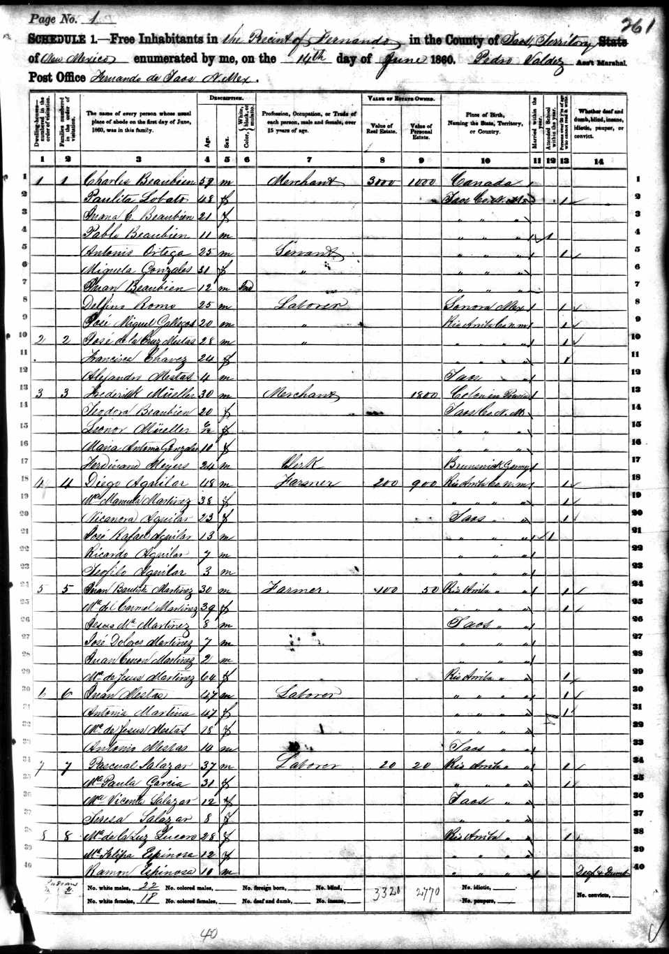

THE MAXWELL LAND GRANT

"A Native of Kaskaskia, IL. A Fur trader and trapper who by industry, good fortune and trading became sole owner in 1864 of the largest single tract of land owned by any one individual in the US. Maxwell founded the First National Bank of Santa Fe, New Mexico. He was an investor $250,000 to help build the Texas Pacific Railroad. Dynamic … Charitable … Lavish ... One of the great builders of the American West. Died in quiet retirement, July 25, 1875 at Fort Sumner, NM. Born September 14, 1818.

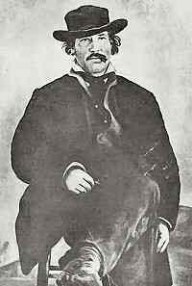 Lucian Bonapart Maxwell

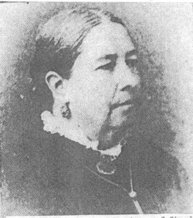 Luz Beaubien Maxwell 1811 - 1864

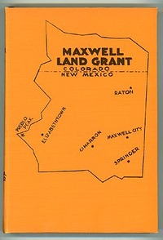

The land grant was over 2,000,000 acres.

1841 | - Charles Beaubien and Guadaloupe Miranda receive the original grant.
1842 | - Lucien B. Maxwell arrives and marries Beaubien's 15 year old daughter Luz.
1846 | - US Army invades the region and New Mexico is incorporated as a US Territory. Maxwell andKit Carson guide Colonel Freemont to California.
1848 | - Beaubien turns over management of grant to Maxwell. The Treaty of Guadalupe-Hidalgo is signed, ending the Mexican War and officially ceding New Mexico and much of the Southwest to the United States.
1849 | - Maxwell and Kit Carson settle at Rayado.
1850 | - US Army forms official post at Rayado. Maxwell allows them to rent his home and property.New Mexico is declared a territory.
1857 | - Maxwell purchases Miranda's interest in the grant. Cimarron is founded.
1858 | - Beaubien requests confirmation of the grant and Congress approves. Maxwell builds home inCimarron.
1860 | - Prospectors begin to explore the area.
1861 | - Confederate Invasion of territory. All mining activities suspended for 2 years. Cimarron officially established.
1864 | - Beaubien dies leaving Maxwell his interest in the grant. Maxwell and his wife purchase all other interests in the grant and become sole owners. Maxwell builds the Aztec Mill.
1865 | - Civil War ends.
1866 | - Gold discovered on Baldy Peak. Maxwell considers selling the grant but decides to postpone.
1867 | - Captain William Moore founds Elizabethtown. Moore, Maxwell and other entrepreneurs form the Copper Mining Company. The entrepreneurs also make plans for the building of "The Big Ditch" to divert water from the Red River.
1868 | - Maxwell founds Virginia City, just 6 miles from Elizabethtown.
1869 | - Colfax County incorporated. Maxwell requests a survey of the grant from the State Surveyor General. Survey information is forwarded to Department of Interior in Washington who rules that the grant should not have been made for more than 22 leagues (about 96,000 acres).
1870 | - Virginia Maxwell marries Captain Keys on the third floor of the Aztec Mill and Maxwel refuses to attend. Maxwell sells his interest in the grant and moves to Fort Sumner.
1872 | - Elizabethtown is dying and county seat is moved to Cimarron.
1875 | - Maxwell dies at Fort Sumner in poverty. The new grant owners attempt to extract rents from squatters or kick them off the land. Reverend Toby fights the Grant men and is found murdered. The Colfax County War begins.
1879 | - New Mexico again surveys the property and upholds the original grant which includes the full 1,714,764.93 acres.
1881 | - Billy the Kid shot and killed at Maxwell's last home in Fort Sumner, New Mexico by Pat Garrett.
1882 | - Cimarron loses county seat to Springer.
1886 | - US Circuit Court upholds New Mexico's 1879 decision.
1887 | - US Supreme Court confirms the lower courts decisions.
1890 | - Use of the Big Ditch is discontinued.
1912 | - New Mexico declared a state.
1922 | - Oklahoma millionaire Waite Phillips purchases 300,000 acres of the grant.
1938 | - Waite Phillips donates 35,857 acres to form the Philmont Scout Ranch.
1941 | - Waite Phillips donates an additional 91,000 acres to the Philmont Scout Ranch as well as his 23 story Philtower building in Tulsa, Oklahoma.
1963 | - Norton Clapp purchases an additional 10,098 of Baldy Mountain mining area and donates to Philmont Scout Ranch.

The Maxwell Land Grant connects to the Colfax County War, and the Maxwell home in Fort Sumner is where Billy the Kid died at the hands of Pat Garrett. These people, along with Lucian and his son Peter Maxwell connect to the Santa Fe Ring.

